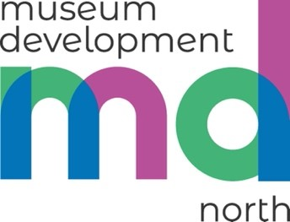
Access Review 2026

A Research
In advance of the site visit, museums will answer basic questions about their current access provision and supply any supporting materials.

B Site visit - half day
- Meeting and walk and talk with the museum lead/team to discuss their challenges, current focus and aims for making the museum more accessible
- Liz will then survey the site on her own- with focus on the visitor journey

The survey will include:

External Environment | Internal Environment | Resources & Communication Methods for Specific Groups
- Approach to building  - Car parking  - External ramps, steps and handrails | - Entrances  - Doors  - Floor surfaces  - Reception desks and service counters  - Lift  - Toilets  - Wayfinding information and signs  - Gallery interpretation  - Communication systems and acoustics  - Lighting  - Switches and controls | - Information methods  - Website (basic review)  - Recommendations on developing resources  - Reference to resources for specific groups – e.g. for children with special educational/additional needs’  Recommendations can be tailored to specific groups – for example if the museum is planning to work with people with Dementia or neurodivergent visitors

C Access Report
This is designed to be a useful starting point for museums who want to make their site and services more accessible. It will be a short report in tabular format including photographs. Although it will not be to the level of a formal access audit relating to British Standard 8300 for accessible and inclusive environments, reference will be made to Approved Documents - GOV.UK. It will consider how well the environment and method of delivery meet the needs of existing and potential users. A traffic light system/coding may be employed to look at quick wins (things that you can do quickly and at no/low cost) vs long term improvements that require a high level of funding. There will also be signposting to useful FREE resources.

D Follow-up online meeting
An online meeting will be offered 1 month after the report has been supplied. This will be an opportunity to discuss recommendations and, if required, Liz will support the museum to complete an action plan.

Please contact Liz Denton to find out how to apply: liz.denton@museumdevelopmentnorth.org.uk

