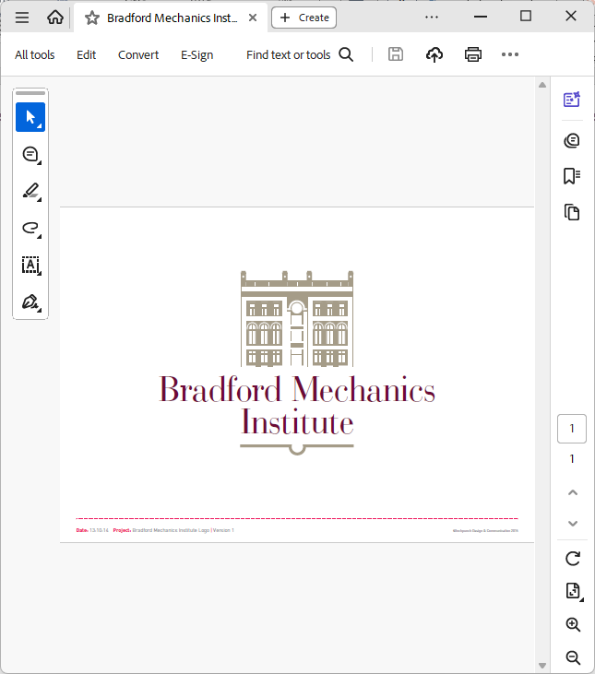

**Heritage Events Officer (Bradford Heritage Stories)**

This is an exciting new role supported by the Heritage Fund. The Bradford Mechanics Institute was conceived in 1825, began operating fully in 1832 and, for 200 years, has been at the heart of city life.

We’re looking for a lead person to turn our project plan into memorable themed events, vibrant exhibitions and presentations reflecting how the Institute’s people and events contributed to the development of Bradford as an economic powerhouse, progressive civic authority and international cultural hub.

The appointee will work alongside our Finance Officer, Premises and Room Hire Officer and Heritage Research Officer.

**Key Responsibilities**

+ Develop and deliver inclusive events and exhibitions based on Mechanics Institute research reflecting the breadth of Bradford’s heritage and people

+ Collaborate with community groups, artists and researchers to create content and display materials

+ Support accessible, participatory programming that reflects Bradford’s diversity

+ Contribute to legacy planning, documentation, and evaluation

+ Support our Library team as needs arise

**Skills and Experience**

+ Researching, analysing and interpreting heritage

+ Creating engaging displays

+ Project-management and leadership

+ Marketing events

+ Working with contracted 3rd party artists and speakers

+ Excellent written communication, record keeping and evaluation skills.

We’re an inclusive employer and welcome applications regardless of background, demographic or other characteristics.

**Location:** Bradford Mechanics Institute, BD1 1SZ

**Contract:**Fixed-term, 15 months, 21 hours per week (3 days) **Salary:**Up to £27,898 pro rata

**Application Deadline:** Sunday 2nd November 2025, 11pm

**Interviews:** Week commencing 10th November, in person at The Mechanics Institute

**How to apply:** send your CV and covering letter (up to 250 words) to [bmi-library@talktalk.net](mailto:bmi-library@talktalk.net) or by post to The Mechanics Institute, 76 Kirkgate, Bradford BD1 1SZ.

Alternatively, a short video (up to 3 minutes) can be sent via WeTransfer.

