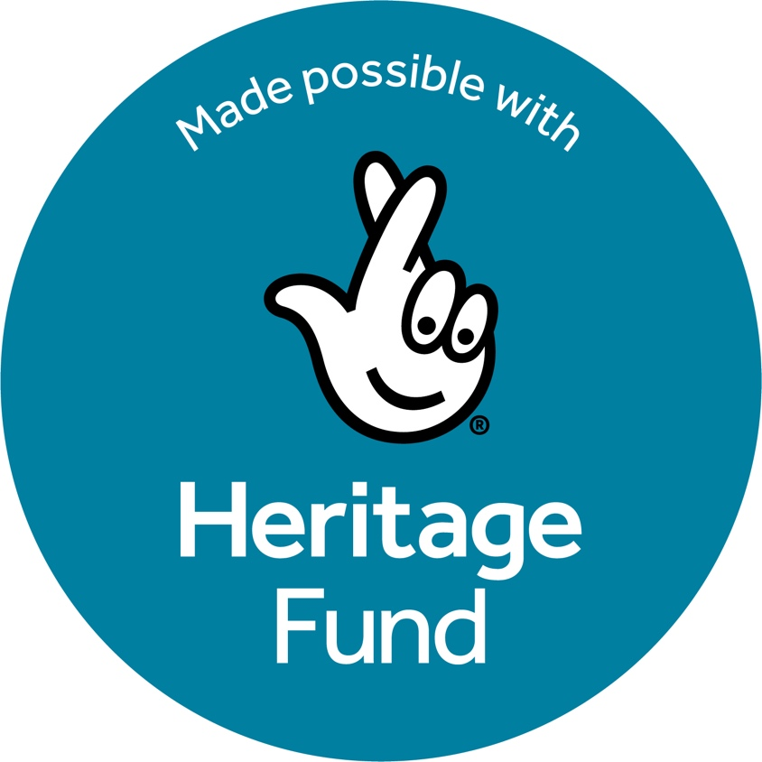

# **Museum Development North**

# **Future Preparedness Grants Guidance**

**Issued September 2025**

## **What is the aim of the MD North Future Preparedness Grants scheme?**

The Future Preparedness Programme is made possible with The National Lottery Heritage Fund. Thanks to National Lottery players, we have been able to design a programme to support museums in the north of England to respond to and prepare for climate disruptions through a series of workshops, bespoke support, events and a funding opportunity.

The aim of the Future Preparedness Grants scheme is to support museums to be able to conduct and commission the necessary research, reports and surveys to inform action plans for future resilience, build evidence for advocacy, and support future planning and funding applications for capital development to improve the long-term sustainability and environmental resilience of existing museum buildings and collections.

We encourage museums to submit grant applications that build on the advice and support of MD North and from participation in the wider Future Preparedness Programme. **You must contact Kaye Hardyman or Sue Hughes at Museum Development North if you are planning to apply.** You can find their contact details here on our website: <https://www.museumdevelopmentnorth.org.uk/?post_type=team>

## **What will we fund?**

The Future Preparedness Grants can support:

* Work towards RIBA stage 0 to 3[1]
* Assessment of and research into climate-related environmental risks and resilience of buildings and collections, now and looking into the future
* Commissioning building surveys and reports including condition surveys, climate risk assessments with recommendations, and conservation management plans
* Planning for maintenance, climate adaptation and mitigation, and decarbonisation
* Conducting research and compiling evidence to support advocacy for capital development fundraising
* Developing costed action plans

You must show that your project has been developed in line with existing forward plans or other key policy and planning documents, including Accreditation Development Areas.

Funding may support you to deliver on actions arising from your participation in the wider Future Preparedness Programme.

**We can fund:**

* Materials and equipment
* Contracting freelancers or other specialists to increase expertise or capacity
* Research and development costs
* Additional resourcing to enable staff/volunteers to dedicate time to this work and develop skills

**We will not fund:**

* Capital building work
* Revenue costs, such as existing salaries and general running costs
* Ongoing capital or maintenance costs
* Any expenditure for which the museum cannot provide evidence (e.g. receipts)
* Costs incurred prior to the project start date

**Alternative funding:**

If you have a project in mind requiring longer timescale or that is for capital development work, you might want to consider applying directly to The National Lottery Heritage Fund. For advice on alternative sources of funding please contact your Museum Development Adviser.

## **Who can apply?**

The following museums are eligible to apply for a Future Preparedness Grant:

* Museums in the north of England which are Accredited, hold provisional status, or are formally Working Towards Accreditation[2].

The following museums are not eligible:

* National Portfolio Organisations and DCMS sponsored National Museums, English Heritage and National Trust sites, and unaccredited museums.

## **How much can you apply for?**

Individual organisations can apply for up to £10,000 for their project with a minimum of 10 grant awards expected. There is one round of funding with £100,000 available in this scheme. We expect most grant applications will be in the region of £5,000 to £10,000.

**Please note** that you may not be offered the full amount you apply for.

Match funding is not a requirement but confirmed match funding will demonstrate a commitment to the project and will be considered when reviewing the applications.

## **When and how can you apply?**

Future Preparedness Grant scheme opens for application on 6 October 2025 and closes at 4pm on 6 February 2026. Only one application should be submitted from your organisation. You must allow adequate time for the award process before starting your project. Any work started prior to completion of signing the grant award letter it at your own risk. Applicants will be informed of the outcome the week of 23 March 2026 with initial grant payments processed in early April 2026.

You must complete your application on the online form. The link for the online application is here and will be open to applications from the 6 October 2025: <https://online1.snapsurveys.com/w5ln7v>

A Word version of the questions, which includes prompts on what information we will be looking for, to help you draft your application can be found here: ADD LINK

**You must contact Kaye Hardyman or Sue Hughes at Museum Development North if you are planning to apply.** You can find their contact details here on our website: <https://www.museumdevelopmentnorth.org.uk/?post_type=team>

## **When does the money have to be spent?**

Projects can start on return of the grant acceptance letter. All project funds must be spent and completed with final reports and invoices submitted to MD North by 29 January 2027.

We may release up to 80% of the grant value on signing the grant acceptance letter, with the remainder to be claimed on completion of the project. The final claim can be invoiced on submission of your final report and proof of expenditure. You will only claim the amount you have spent and for which you can provide evidence of spend, up to 20% of the remaining grant.

## **How do we assess applications?**

Your application will be assessed by the MD North team with support from an independent panel of museum and heritage professionals.

**Applicants must discuss their application with MD North before submission. Please contact Kaye Hardyman or Sue Hughes at Museum Development North if you are planning to apply.**

We will be looking for evidence of the following:

* The museum has necessary permissions to conduct your project activity from the governing body and, if you lease the museum building/s, the landlord. We will also want to see that your museum has support to pursue recommendations resulting from the activity
* The project is viable and achievable in the grant timescale with completion by 29 January 2027
* The need for the project is clearly evidenced
* The project has been developed in line with existing forward plans or other key policy and planning documents, including Accreditation Development Areas
* Clear aims and objectives with outcomes that demonstrate the impact of funds
* Details outlining when and how the project will be implemented to demonstrate it is clearly planned
* The project demonstrates value for money – costs are appropriate to the scale and nature of your project along with details of any match funding or contributions in-kind
* The project will be completed on time with likely risks to delay identified and mitigated

Applicants will also be asked to demonstrate how they have considered:

* Best practice when working with freelancers/consultants[3]
* Follow The National Lottery Heritage Funds Digital good practice guidance[4] and Procurement good guidance practice[5]
* Environmental sustainability in response to the climate crisis
* Any likely impacts the project may have on equity, diversity and inclusivity

## **Do I need to submit anything with my application?**

You can upload up to seven additional supporting files with your application. The following are mandatory:

* Evidence of having the necessary permissions to conduct your project activity from the governing body and, if you lease the museum building/s, the landlord. If you are a lease holder, you should check the terms and conditions to see who holds the repairing responsibilities
* Evidence that your museum has support from the governing body and, if applicable, the landlord to pursue recommendations resulting from the activity
* Your Governing Document (unless you are a public sector organisation)

You may also want to upload additional files to support your application, such as:

* How the project links to organisational plans and policies
* Your project costs, this may include a detailed budget spreadsheet
* Briefs for tender you intend to advertise, or copies of quotes you have received
* Images or other media that help visualise written descriptions in your application

## **What are the key dates?**

This funding will be a single-stage process. You need to allow enough time for funding decisions to be made before you start your project.

|  |  |
| --- | --- |
| Key Dates | Activity |
| 6 October 2025 | Online application form opens for applications |
| 6 February 2026 at 4pm | Deadline for applications |
| 9 February to 6 March 2026 | Assessment of applications |
| Week of 9 March 2026 | Final decisions made |
| Week of 16 March 2026 | Applicants informed of outcome |
| Week of 23 March 2026 | Projects can start on receipt of signed grant agreements |
| From 7 April 2026 | Processing of initial grant payments |
| 29 January 2027 | All project funds must be spent and completed with final evaluation report and invoices submitted |

## **Are there grant conditions and reporting requirements?**

It is a condition that grant recipients do the following:

* Send a copy of recent accounts or last three months of bank statements
* Complete an evaluation report on a template provided by MD North which describes the impact and deliverables of your project
* Evidence of expenditure, sent alongside the invoice and final grant claim form
* Complete the Annual Museum Survey for 2025-26 which will run summer 2026 with registration in April 2026
* Acknowledge funding from The National Lottery Heritage Fund on all print and online marketing materials using logos and guidelines provided by MD North
* Acknowledge ACE and MD North using the wording and logos we will provide
* Follow The National Lottery Heritage Funds Digital good practice guidance[6] and Procurement good practice guidance[7]
* Sign and return the grant agreement form which will define the activities to be delivered and sets out the terms and conditions of the grant
* Contact your Museum Development Adviser if there are any changes or delays with your project

**Please note:** MD North reserve the right to clawback any funding where projects are underspent or where funding has been used for purposes not stipulated in the grant agreement.

**Additional Requirements**

Every museum we support will be expected to share their learning with other museums. This could include:

* Providing a case study or blog post
* Presenting a paper at an MD North event or conference

1. <https://www.architecture.com/knowledge-and-resources/resources-landing-page/riba-plan-of-work>
2. Recognised as Working Towards Accreditation by Arts Council England through the allocation of a reference ‘T’ number
3. More information on working with freelancers can be found [Contracts, Work Plans and Working Effectively with Freelancers - GEM,](https://gem.org.uk/resource/contracts-work-plans-and-working-with-freelancers/) [Calculating Day Rates For Freelancers - GEM,](https://gem.org.uk/resource/calculating-day-rates-for-freelancers/) [Working with freelancers - Museums Association.](https://www.museumsassociation.org/careers/freelancers-week/working-with-freelancers/)
4. <https://www.heritagefund.org.uk/funding/good-practice-guidance/digital>
5. <https://www.heritagefund.org.uk/funding/good-practice-guidance/procurement>
6. <https://www.heritagefund.org.uk/funding/good-practice-guidance/digital>
7. <https://www.heritagefund.org.uk/funding/good-practice-guidance/procurement>