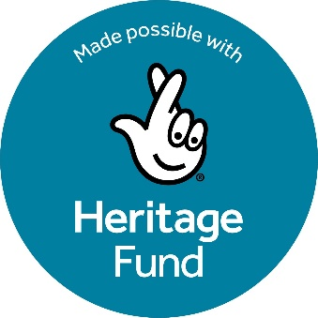 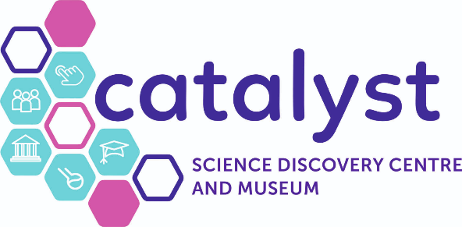

**The Synergy Project**

**Volunteer Co-ordinator - Job Description**

**Job Title:** Volunteer Co-ordinator

**Reports to:** Synergy Project Manager

**Job Purpose:** To lead, grow and manage the volunteer programme at Catalyst

**Location:** Catalyst Science Discovery Centre and Museum, Mersey Road, Widnes, Cheshire, WA8 0DF

**Schedule:** 37.5 hours a week. 5/7 days working flexibly according to the needs of the program and volunteers

**Salary:** £26,421 per annum

**Contract:** Fixed Term to March 2028

**Reporting Staff:** Volunteers

**Background:**

Catalyst is undertaking an exciting new project. In 2022, the National Lottery Heritage Fund awarded Catalyst funding for the Development Stage of the Synergy Project which aims to make our heritage accessible to new and underrepresented audiences in an exciting and meaningful way. The project will physically redevelop the heritage galleries and transition spaces, as well as implement a heritage education offer to complement our already successful STEM programme.

During the Development Phase, co-creation consultants worked directly with our target audiences within the local community to ensure that the interpretation and activities of the Synergy project are codesigned and co-created. The themes for the heritage galleries recommended by the co-creation consultants are:

* Our Place
* Our Industry
* Our Lives/People
* Your Chemicals

Our target audiences were also consulted on display and accessibility requirements.

In September 2024, Catalyst was awarded the funding for the Delivery Phase of the Synergy Project which will see the physical implementation of the new heritage galleries and heritage offer.

**Key Responsibilities:**

* Work with departmental managers to develop and enhance our volunteer programme.
* Develop and deliver a volunteer advertising and recruitment programme, including exploring a range of new approaches
* Develop and deliver a volunteer training manual, including a personal development plan for each volunteer
* Develop and deliver an on boarding and monitoring process for volunteers
* Work with departmental managers to manage assignment of volunteer roles
* Train, assist and oversee volunteers as they carry out heritage/ education/ guest activities
* Undertake an annual review of the volunteer programme, in conjunction with volunteers and staff, and update and make regular reports to the Synergy Project Management Group

**Knowledge/Skills:**

Necessary

* Excellent written and verbal communication skills
* Strong interpersonal skills
* Excellent organisational skills with the ability to prioritise own workload/tasks and work under pressure
* Ability to work independently and part of a team
* IT literate with experience of using Microsoft Office Software
* Knowledge of policies relating to volunteering and how to develop and implement these

Desired

* Knowledge of the history and demographics of the local area

**Experience and qualifications:**

Necessary

* Proven experience leading volunteering activities and/or volunteer management
* Educated to GCSE level or above
* Experience developing volunteering programmes or public engagement programmes
* Experience in delivering training
* Experience in recruiting through various channels
* Advanced DBS check

Desired

* Experience working in the heritage/museum sector
* Experience working on NLHF projects

**Recruitment Timeline:**

To apply please submit a cover letter and CV to [jobs@catalyst.org.uk](mailto:jobs@catalyst.org.uk)

Application Deadline: 12th September

Interview Date: 2nd October

Start Date: ASAP