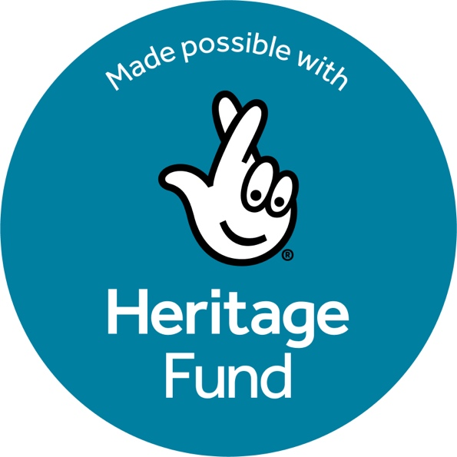
Recruitment Information
MD North Future Preparedness Grants Assessment Panel

Introduction
MD North is recruiting members for a Future Preparedness Grants Assessment Panel. The Panel will help assess applications to one round of Future Preparedness funding, making recommendations to the MD North team.

The Future Preparedness Programme is made possible with The National Lottery Heritage Fund. Thanks to National Lottery players, we have been able to design a programme to support museums in the north of England to respond to and prepare for climate disruptions through a series of workshops, bespoke support, events and a funding opportunity.

The aim of the grants is to support museums to be able to conduct the necessary research and commission reports and surveys to inform action plans for future resilience, build evidence for advocacy, and support applications for capital development funding to improve the long-term sustainability and environmental resilience of existing museum buildings.

The following museums are eligible to apply for a Future Preparedness Grant:
- Museums in the north of England which are Accredited, hold provisional status, or are formally Working Towards Accreditation.

The following museums are not eligible:
- National Portfolio Organisations and DCMS sponsored National Museums, English Heritage and National Trust sites and unaccredited museums.

The Grants will open for application on the 6 October 2025, closing on 6 February 2026. The assessment will take place from 9 February 2026 with the Panel meeting on the 9 March 2026.

The Panel will have up to nine members and be Chaired by a member of MD North. We are looking for Panel members who can support the Future Preparedness Programme Team, bringing their museum sector experience and insights.

The Panel members, together, will bring a wide range of knowledge and expertise to the group that represents the experience of people working across the broad range of museums in the North.

Please note: Museum Organisations that Panel members represent will not be eligible to apply for funding.

What will you have to do?
Grant assessments will be made by the Panel and submitted remotely on a template provided by MD North ahead of an online Panel meeting where applications and recommendations are discussed. There will be a minimum of two weeks to assess the applications. The online Panel meeting will take place on 9 March 2026, 1.30 to 4pm.

Panel members are expected to declare any direct or perceived conflicts of interest before the online assessment meetings.

Confidential or sensitive information may be shared with the Panel through the application assessment process and members are required to maintain confidentiality.

Key Dates | Activity
6 October 2025 | Open for applications
6 February 2026 at 4pm | Deadline for applications
9 February to 6 March 2026 | Panel considers applications
Week of 9 March 2026 | Final decisions made
Week of 16 March 2026 | Applicants informed of outcome
Week of 23 March 2026 | Projects can start, once funding agreements are signed
29 January 2027 | All project funds must be spent and completed with final evaluation report and invoices submitted

Role Description
We are looking for Panel Members who:
- Understand the experiences of people working in museums
- Understand the current issues and opportunities for the sector relating to climate change- its risks and impacts to buildings, collections and estates
- Have existing or emerging knowledge, skills or experience in one or more of the following:
  - Governance and leadership: including strategic planning for environmental sustainability
  - Operations and facilities management or building maintenance
  - Collections care and management
  - Experience of capital development projects of heritage buildings

Previous Board or Committee experience is not essential

What’s in it for you?
By being part of the Future Preparedness Assessment Panel, we hope Panel members will:
- Gain or develop experience of playing an advisory role in a development support programme, supporting their own CPD
- Gain a broader understanding of the museum sector across the North
- Be supporting the development of museums across the North
- Have the opportunity to undertake Carbon Literacy training with MD North

To help Panel members perform their role, MD North will provide:
- An induction pack for new members
- The date for the Panel meeting in advance
- A template to help you record your assessments of applications
- Be on hand to support you with any questions around the process

How do I apply?
To apply for this role, we ask you to please complete the online Expression of Interest Form which includes space for you to provide:
- What knowledge, skills and experience you can bring to the Panel
- A supporting statement that outlines your interest in joining the Panel

Please submit your expression of interest online via this Expression of Interest Form by 6pm on 5 September 2025. Please contact Kaye.Hardyman@museumdevelopmentnorth.org.uk if you want to know more about the role.

July 2025

